|  |  |  |  |  |
| --- | --- | --- | --- | --- |
| **Test Case** | **Execution History** |  |  |  |
| **Start Date** | **Start Time** | **End Time** | **Status** |
| **TC01-Sign In** | **21/01/2019** | **11:48:13** | **11:48:13** | **Passed** |

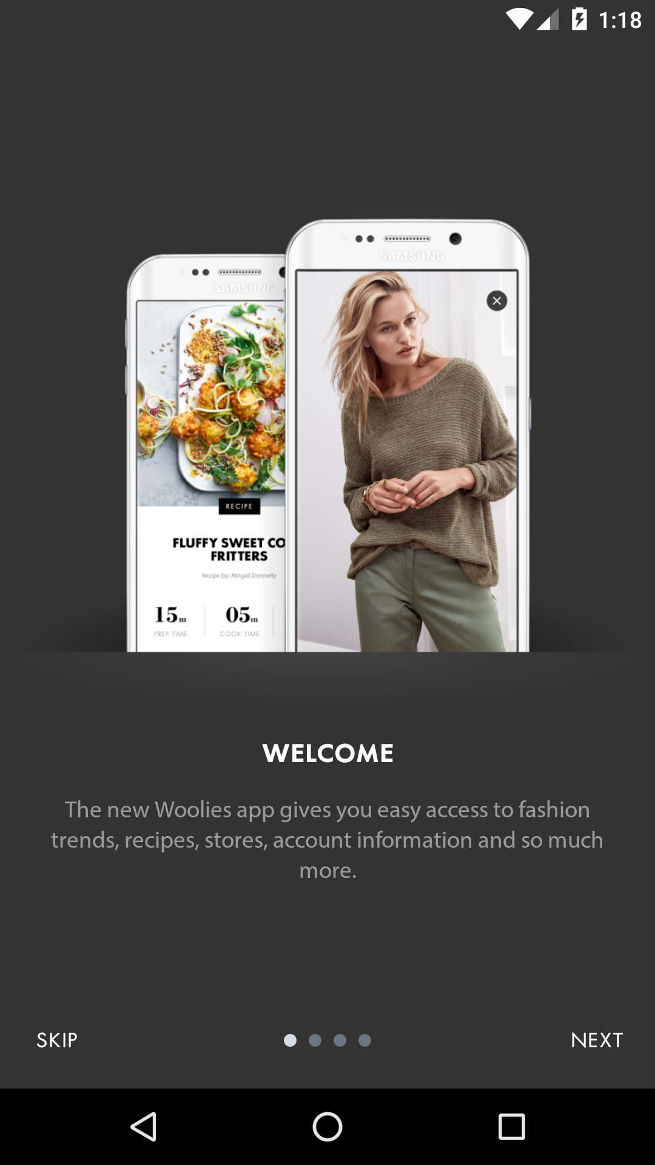

|  |  |  |  |
| --- | --- | --- | --- |
| **Step Description** | **Expected Result** | **Actual Result** | **Status** |
| Step: Open the woolworths mobi one application | Application should open | Application opened as expected | **Passed** |

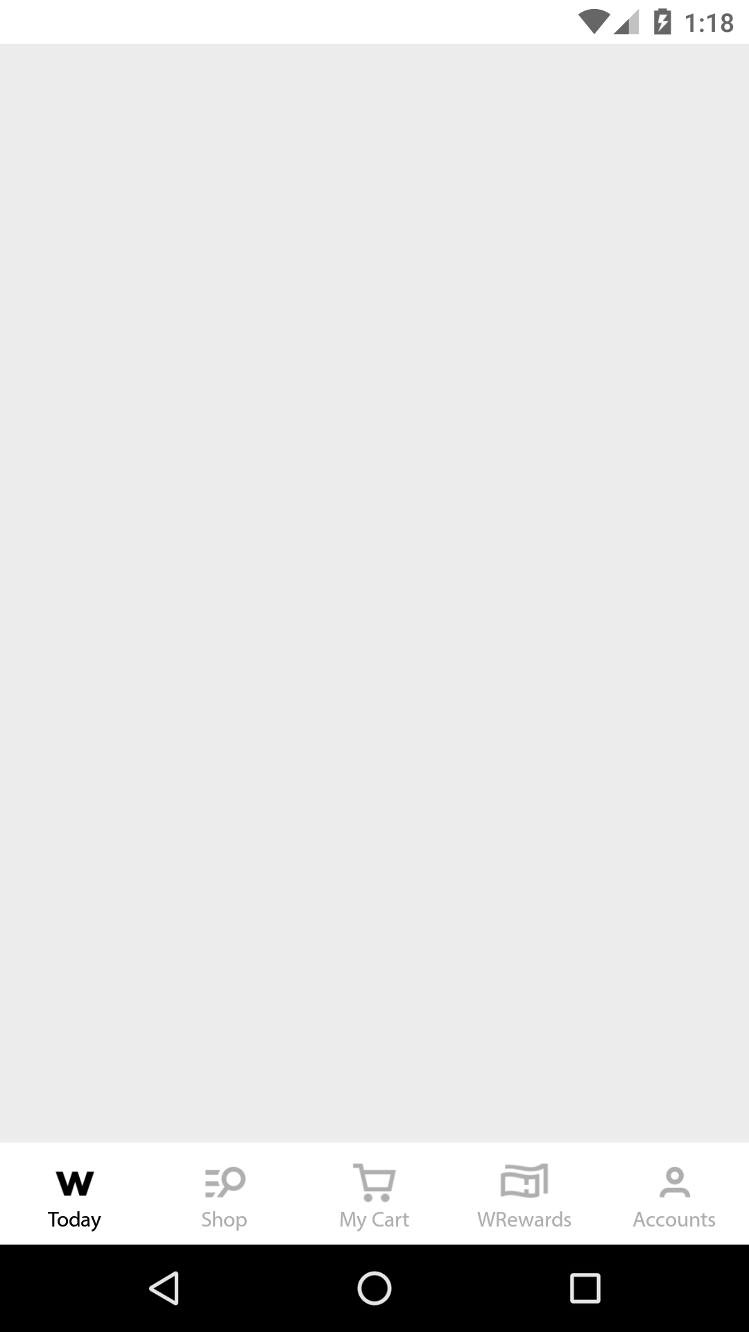

|  |  |  |  |
| --- | --- | --- | --- |
| **Step Description** | **Expected Result** | **Actual Result** | **Status** |
| Step: Click on skip to close the skip page | Skip page should be closed | Skip Page closed as expected | **Passed** |